**Usability Test**

1. **Introduction and Background**
   1. *The reasons for conducting this test*

Although the functional and non-functional requirements have been defined, subjective aspects like user-friendliness and ease of use require real-world testing. User feedback will be crucial in refining these aspects and optimizing the user interface layout for optimal usability. Thus, conducting usability testing plays a key role in developing and designing the suitable website which allows us to identify and address usability issues early on, ensuring that the service is user-friendly, efficient, and meets the needs of users.

* 1. *Introduction*

This usability test aims to collect feedback and opinions from participants regarding the user interface of the website. As the project is in its early stages, it is essential to comprehend how users interact with the UI and identify areas for improvement. To maintain a genuine user experience, participants were recruited who had no prior knowledge or involvement in the development of the SSPS system. Through this test, we seek to gain insights into the UI's usability, user-friendliness, and overall effectiveness.

1. **Methodology**

Participants were requested to complete a Google Form to provide feedback on the aesthetic appeal and usability of the website. They were instructed to rate a screenshot of the page on a scale of 1 to 5 based on their experience. Ratings of 4 or 5 were deemed successful, 3 to 4 were considered acceptable, and scores below 3 indicated a need for modification. Google Forms' built-in features were employed for data collection and analysis, and the findings were visualized using graphs. While recognizing the limited size of the sample, we maintain that the test yielded valuable insights and fostered user involvement in the improvement process by prompting feedback.

Additionally, participants who expressed strong opinions or were particularly impressed were invited to participate in further questioning to gather more in-depth feedback.

1. **Result and analysis**

By analyzing the feedback of over 20 participants, we identified key themes in three areas based on the questions posed and the overall assessment of our website screenshots.

The perceived ease of use of the website received an overall score of 3.9, indicating a favorable rating. Several participants expressed ease in comprehending the website's functionality and navigating its features. However, a small number of individuals indicated initial difficulty in grasping the website's usage. The identified usability issue can be mitigated by providing a comprehensive user guide for new visitors to the website.

An evaluation of the website's aesthetics and design resulted in an average score of 3.93, indicating a wonderful perception among participants. This positive assessment suggests that the majority of survey respondents were impressed by the user interface's visual appeal. Additionally, when asked to rate the color scheme, participants provided a mean score of 4.35, indicating an outstanding rating. While some individuals expressed a desire for a more vibrant color palette, the overall assessment of the color scheme was positive.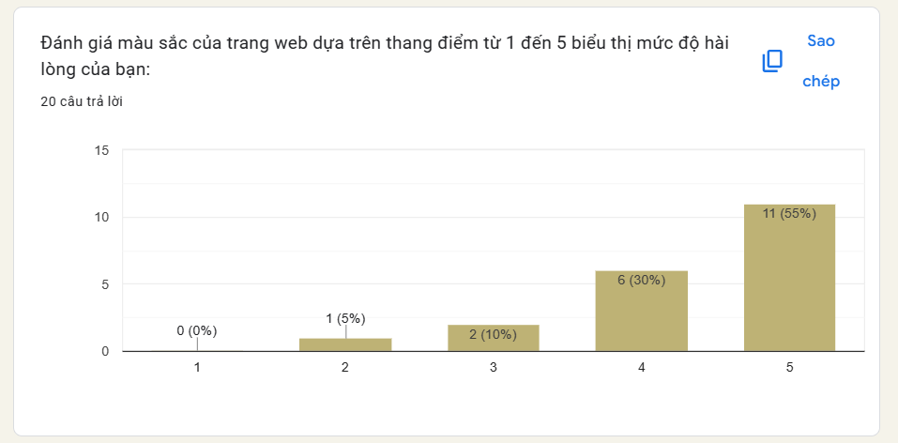

1. **Recommendations and suggestions**

A comprehensive analysis of user feedback gathered through surveys and in-person testing has led to the identification of key recommendations aimed at enhancing the user experience of the SSPS website. The introduction of a support button prominently positioned at the top left corner of the screen would provide valuable assistance to new or older users, facilitating their effective navigation of the website. Furthermore, a revision of the website's color scheme to incorporate a more vibrant and visually appealing palette would further enhance the overall user experience. These proposed modifications would collectively contribute to improving the usability of the SSPS website and ensuring that it effectively caters to the needs and preferences of its user base.

1. **References**

[The link to Google Form](https://docs.google.com/forms/d/e/1FAIpQLScy4ejfR_lWc_4oAZLW9o1HhQZTYyjYIu3rljNyf8QUl-iHJg/viewform?usp=sf_link)